ME 759: Nonlinear FEM

Assignment 3: 1-D Elasto-viscoplasticity

# Equations used for coding

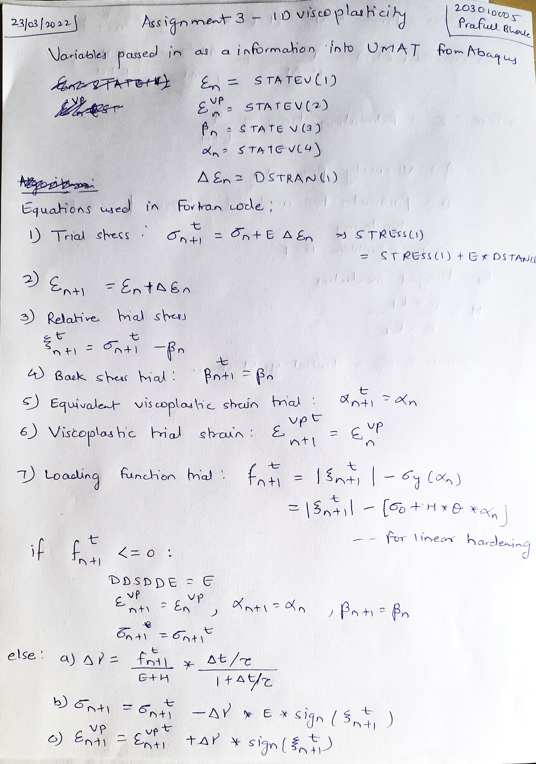

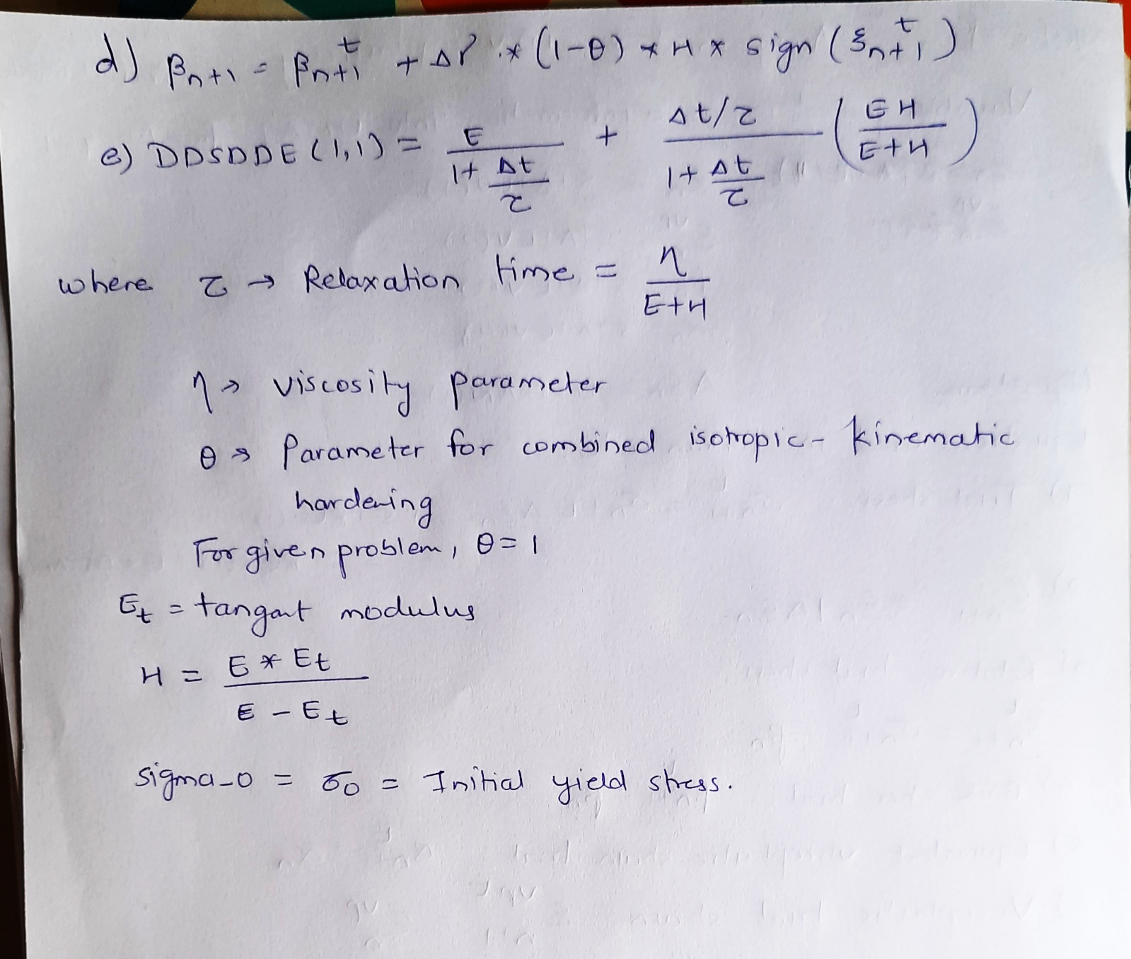

# t = t1

## t1 = 6

### c = 0.005, $Δt=2*\frac{ϵ_{0}}{c}=0.4$

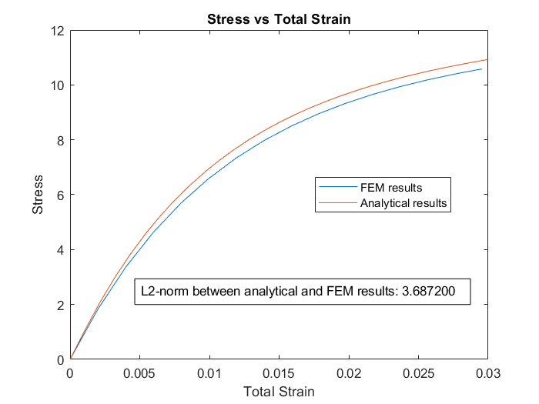

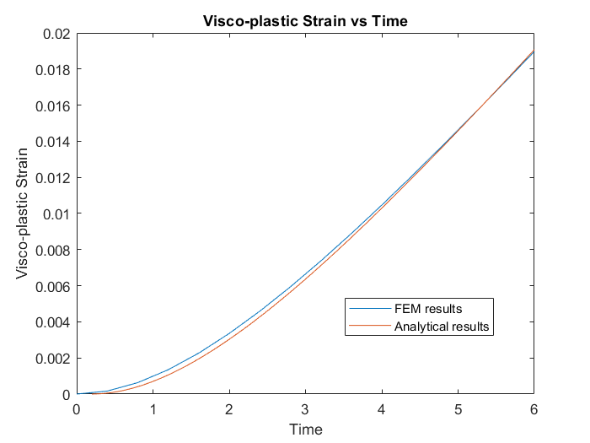

### c = 0.005, $Δt=\frac{ϵ_{0}}{c}=0.2$

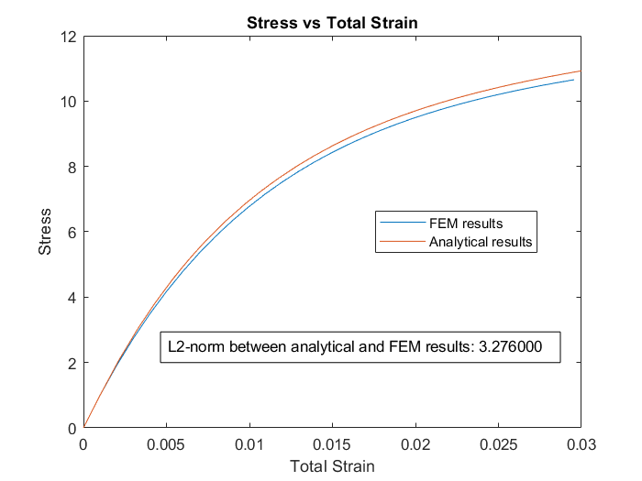

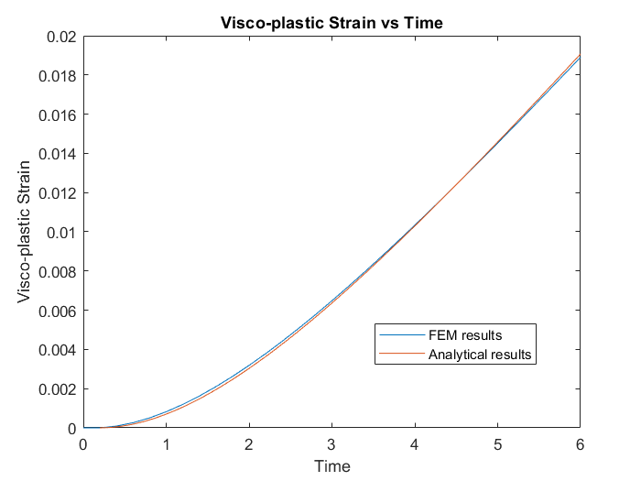

### c = 0.005, $Δt=0.5*\frac{ϵ_{0}}{c}=0.1$

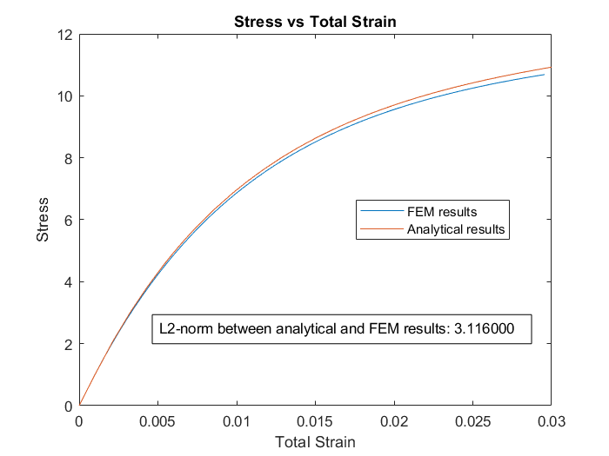

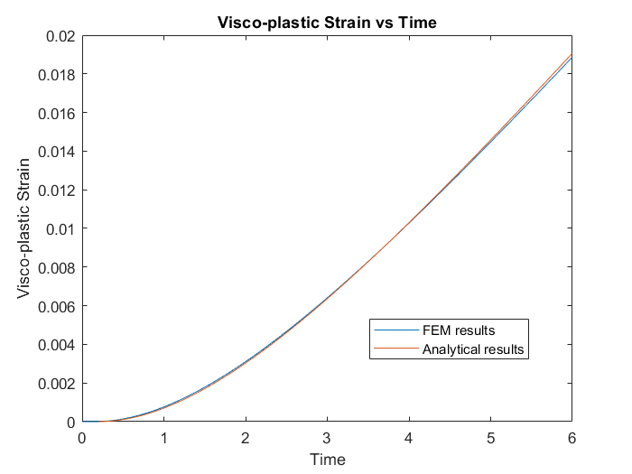

## t1 = 150

### c = 0.0002, $Δt=2*\frac{ϵ_{0}}{c}=10$

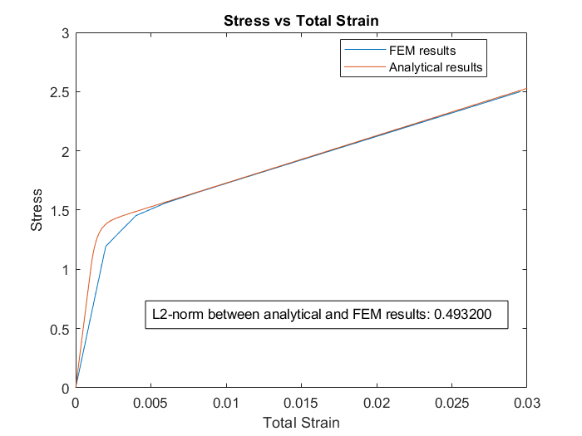

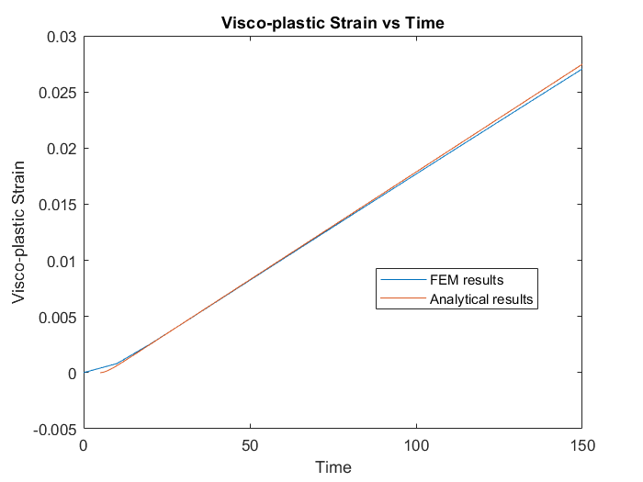

### c = 0.0002, $Δt=\frac{ϵ_{0}}{c}=5$

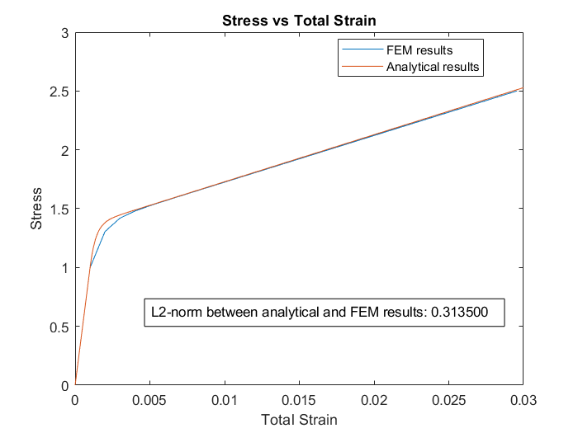

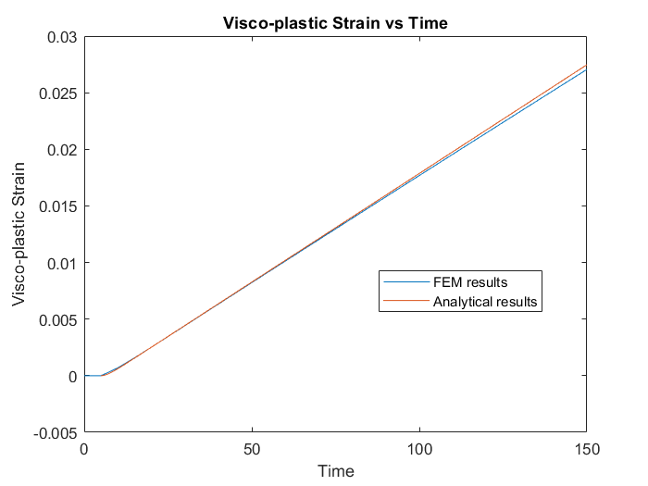

### c = 0.0002, $Δt=0.5*\frac{ϵ_{0}}{c}=2.5$

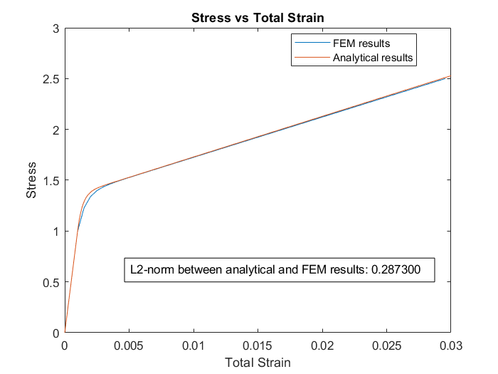

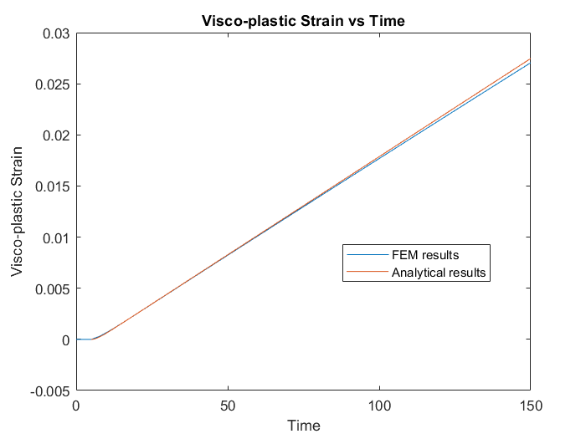

## Observations:

1. The L2-norm between analytical and FEM results was observed to decerease as we reduce the time step $Δt$.

|  |  |  |  |  |
| --- | --- | --- | --- | --- |
| $$Δt$$ | $$L_{2}-norm$$ |  | $$Δt$$ | $$L_{2}-norm$$ |
| 0.4 | 3.6872 |  | 10 | 0.4932 |
| 0.2 | 3.276 |  | 5 | 0.3135 |
| 0.1 | 3.116 |  | 2.5 | 0.2873 |

1. We can also see that as we reduce the time step, the stress-strain plot for FEM comes closer to analytical plot.

# t = 6 * t1

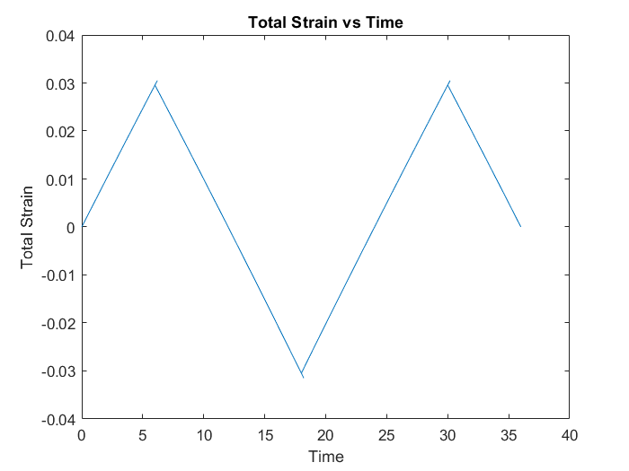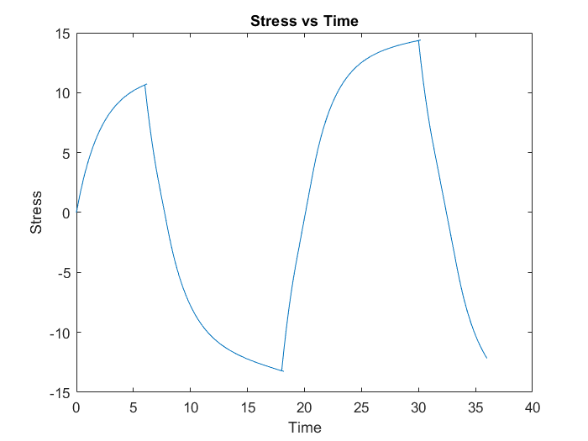

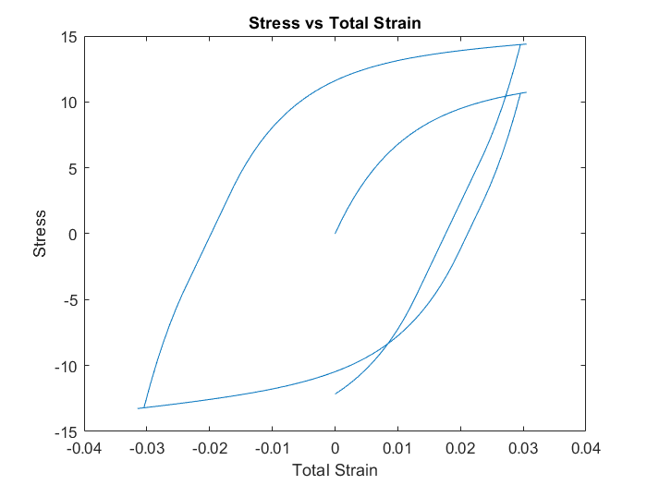

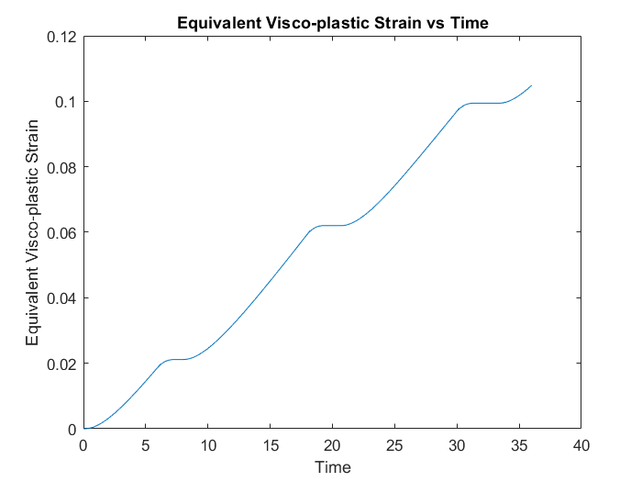

## 

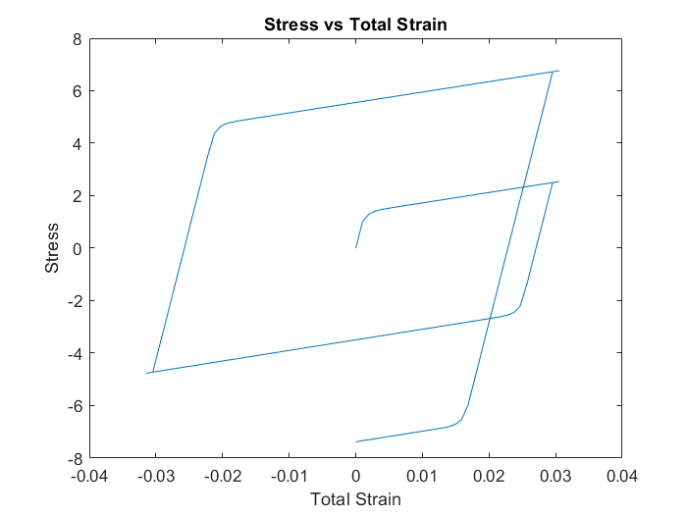

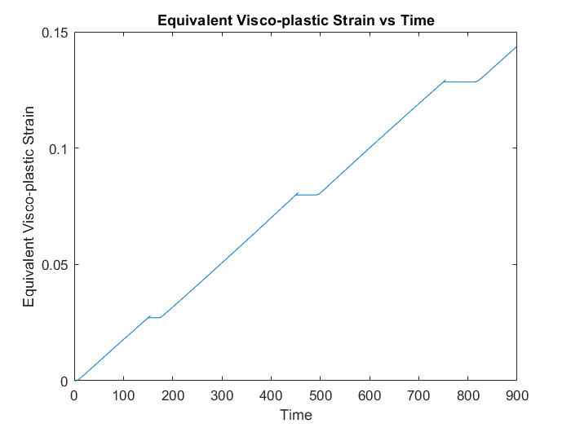

## Observations:

* We can see the strain hardening effect in stress-strain plots